iCyberSecurity Inc.

Team Cyber Dragon | Web Pamphlet Project | May 9, 2016

Software Design Report

UMLs and Test Plan

# Internet Pamphlet Project

Introduction:

This software design is being submitted for review to the management. In the Project Scope Report (PSR) submitted for approval, you received a general outline. This document will discuss the details through a final Agile approach that breaks down the parts for software implementation.

Software Requirements

This software is implemented to provide users with an internet pamphlet interface for the sale of CyberSecurity Inc.’s services. Users are to be able to access their information, while only certain administrators would be able to access all possible information. Public Access of the interface is available for new customers.

It was desired that the pamphlet have the following capabilities:

1. Provide help Option to explain successful intended operation
2. Sales Pitch, including key Selling Points
3. Identify OS environments
4. Concept of Operations
5. Provide 3 service options and prices
6. Logistics and Maintenance Plan with prices
7. Guarantee Policy
8. Testimonials- Customers Satisfied/ unsatisfied
9. Contact Us Methods
10. Read from customer files
    1. Tracks companies in receipt of pamphlet
    2. Customer Ratings/Stats
    3. Key vs. Nice to Have Customers
    4. Unique customer Names
11. Capable of updating the customer list
12. Functionality for new customers (Order a copy of the pamphlet)
    1. Indicate that the pamphlet was sent to the new customer
13. Persistence through executions
14. Ability to order one or more products
15. Administrator Privileges
    1. Change customer Ratings
    2. Key Fields
    3. Address
    4. Add, Delete Customers
    5. View and Print Customer List
    6. Produce a customer listing
    7. Produce a Key customer Listing

Implementation of Project Requirements

In general we approached the problem through a multiple access framework. There is a master customer interface and an administrator interface in addition to general public access. There is an administrator UI and a customer UI accessing data. The pamphlet is posted on demand by the customer.

Admin UI

Adds and Removes customers from the master database. Editing data when needed is possible.

Customer UI

Provides customer user access to interface with us.

Guest Mode

This is the guest mode, available when the program is without a Logged-in User (Everyone Logged Out).

The initial project window (when the project is initiated) has several managerial functions. When no one is logged in it demonstrates in “Guest Mode”, displaying Testimonials, and enticing people to buy our product. People are able to request a pamphlet prior to ordering our services. If a party wishes to order our product, it will prompt to add that customer to our list of customers, and send a pamphlet. These diagrams should be self explanatory.

Database

The database, managed by an SQL Lite framework, is accessible by the Aministrative User. The customer practically adds themselves

# UML





From the above diagrams, we visually see that the Administration UI works behind the scenes to manage customer and communicate to us. Our customers have the ability to tell us who they are, request pamphlets from us, while we track their orders.

Admin UI Descriptions

QmainWindow

Contains methods for other derived classes. Master

Customer List

Admin User Interface

Add Customer Window

Input prompt to Add customer upon demand

Customer Info

Extended information display, address information

Remove Window

Input prompt to Delete customer upon demand

Admin Interface



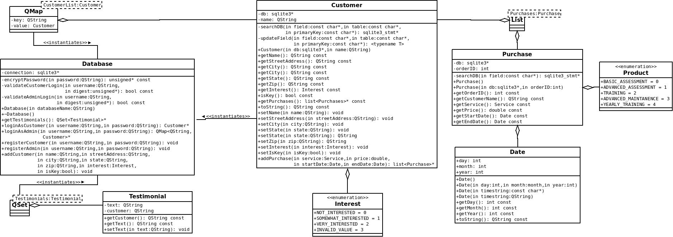Customer Interface

Qmap

Hashmap manager, linked to the database and the customer class.

Customer Class

The customer class manages the customer’s address data, searches the database, and links to the purchase class via the list class.

Interest Class

The interest class stores the customer interest level, not at all, somewhat or very interested in the product.

List Class

Base Class List that manages Purchases

Purchase Class

Derived class managing the functions of purchasing the pamphlet / software.

Date Class

Derived class tracking the date of the purchase

Product Class

Tracks aspects of the product after purchase. Whether a company wants a basic or advanced assessment, training or is involved with the maintenance plan.

Database

Manages the login / logout and access to customer data via SQL Lite. Requests whether a user is an Admin User or a Customer, adds customers or registers Customers and admin users.

QSet

(Base Class) Controls access to the testimonial class.

Testimonial

Stores feedback of the customers who submit feedback. Publically available as an advertising tool.

# Use Cases





# Use Case Statements

**Class Diagram Content**

**Name:** mainwindow

**Attributes:** salesPitch: Qstring

conceptOfOperations: QString

serviceOptions: Qstring

maintenancePlan: Qstrig

guaranteePolicy: QString

**Methods:**  login:

openRequestPamphlet:

openOrderProducts:

openDisplayTestimonials:

**Name:** requestPamphlet

**Methods:** submitAddressData: QString

**Name:** orderProducts

**Attributes:**  displayProductChoices: QString

**Methods:** submitAddressData: QString

**Name:** displayTestimonials

**Attributes:**  testimonials: QString

**Methods:** submitTestimonial: QString

**Use Case Content**

**Access Pamphlet Data on Splash Screen**

Use Case Number: 1

Application: iCyberSecurity non-login access

Use Case Name: Pamphlet Data

Use Case Description: Access to the various data entries regarding the sales pitch, the concept of operations, the service options, the maintenance plan, and the guarantee. Anyone can access this information.

Primary Actor: Anyone who opens the program should have access to this information

Precondition: None

Trigger: Opening the program

Basic flow: User opens program, reads through data

Alternate flows: Unless the program fails, or the data is corrupted, this use case has no alternate flows or exceptions

**Read or submit testimonials**

Use Case Number: 2

Application: iCyberSecurity non-login access

Use Case Name: Testimonials

Use Case Description: User can open the testimonials section and immediately read other users submitted experiences. In a window below the testimonials, they may submit their own and immediately see the testimonial added.

Primary Actor: Anyone who opens the program should have access to this functionality

Precondition: The program should check that this person is a verified customer

Trigger: Opening the testimonial section on the splash menu.

Basic flow: The program operates normally, specifically, the database displays information in the testimonials window without problems, and the window accepts data from the customer, displaying it on submission.

Alternate flows: The database becomes corrupted, or the program does not start

**Request pamphlet by mail to address**

Use Case Number: 3

Application: iCyberSecurity non-login access

Use Case Name: Mail pamphlet

Use Case Description: User can enter their address and be entered into data base, for processing to send to their address.

Primary Actor: Anyone who opens the program should have access to this functionality

Precondition: None

Trigger: Access order window and enter address

Basic flow: The user opens the program, opens the order window, and enters address. The database accepts the address

Alternate flows: The program fails to open, the window fails to open, or the database fails to accept the data entry

# Test Plan- Black Box Methodology

Testing tool:

Include QtTest

Testing Admin UI Functions

Functions to Test

Testing Customer Interface Functions

Functions to Test